 | Filing Reference : |  | GG/COMS/TS.2/13
 | Document Title : |  | Use-Case Realization Report (Analysis)  Manage Workflow Step
 | Version : |  | 1.0
 | Prepared By : |  | Alvin Chang
 | Date Created : |  | Monday, Jul 30th, 2011
Approved By :
 |  | Tran Ba Tien |  | Date
 |  | Project Manager |  | 30th Jul 2011
©2011 [Hoang Kim joint stock Company].
The information contained in this document is the property of [Hoang Kim joint stock Company]. The contents must not be reproduced, wholly or in part, for purposes other than for which it has been supplied, without the prior permission of [Hoang Kim joint stock Company], or, if it has been furnished under contract to another party, as expressly authorised under that contract. [Hoang Kim joint stock Company] shall not be liable for any errors or omissions.

Revision History
Date | Issue | Description | Author
30/JUL/2011 | 1.0 | First version | Alvin Chang

Table of Contents
1. Brief Description 4
2. Flow of Events 4
3. Interaction Diagrams 4
3.1 Add Workflow 4
3.2 Initiate \ Update Workflow UI 5
3.3 Activate \ Deactivate Workflow 5
3.4 Add Step 6
3.5 Modify Workflow Properties 6
3.6 Modify Step Properties 7
3.7 Activate \ Deactivate Step 8
3.8 View Workflow 8
3.9 Modify Workflow-Step Relationship 9
4. Participating Objects 9
5. Class Diagrams 10
5.1 Manage Workflow-Step 10

Use-Case Realization Report
Manage Workflow-Step

Brief Description
This use case enables a department manager to manage the workflows and the steps included in the workflows. For workflows, this includes adding of new workflow, updating workflow properties, and activating / deactivating workflows. For steps, this includes adding of new steps, updating step properties, and activating / deactivating steps. It also includes the managing of the workflow-step relationships.

Flow of Events
The standard flow of events for this use case and any exceptions are described in the following subsections. See section 3 for an overview of the participating Actors and Domain Objects.

2.1 Add Workflow (Standard Flow)

- Department Manager navigates to WorkflowMainUI.
- Department Manager selects to add a new workflow, and WorkflowPropertiesUI is shown.
- The relevant workflow information is entered, and saved.
- Department Manager will be shown the WorkflowMainUI with the newly created workflow.
- This marks the end of this use case.

2.2a Deactivate Workflow (Standard Flow)

- Department Manager navigates to WorkflowMainUI.
- Department Manager selects an active workflow from the list of workflows.
- Department Manager selects deactivate option to deactivate the workflow.
- This marks the end of this use case.

2.2b Activate Workflow (Standard Flow)

- Department Manager navigates to WorkflowMainUI.
- Department Manager selects a deactivated workflow from the list of workflows.
- Department Manager selects activate option to activate the workflow.
- This marks the end of this use case.

2.3 Modify Workflow Properties (Standard Flow)

- Department Manager navigates to WorkflowMainUI.
- Department Manager selects a workflow from the list of workflows.
- Department Manager selects Modify Workflow Properties option, and the WorkflowProperties UI will be shown.
- Department Manager will enter the updated workflow properties and submit.
- This will return control to the WorkflowMainUI
- This marks the end of this use case.

2.4 Add Step (Standard Flow)

- Department Manager navigates to WorkflowMainUI.
- Department Manager selects to add a new step, and StepPropertiesUI is shown.
- The relevant step information is entered, and saved.
- Department Manager will be shown the WorkflowMainUI with the newly created step.
- This marks the end of this use case.

2.5a Deactivate Step (Standard Flow)

- Department Manager navigates to WorkflowMainUI.
- Department Manager selects an active step from the list of steps.
- Department Manager selects deactivate option to deactivate the step.
- This marks the end of this use case.

2.5b Activate Step (Standard Flow)

- Department Manager navigates to WorkflowMainUI.
- Department Manager selects a deactivated step from the list of steps.
- Department Manager selects activate option to activate the step.
- This marks the end of this use case.

2.6 Modify Step Properties (Standard Flow)

- Department Manager navigates to WorkflowMainUI.
- Department Manager selects a step from the list of steps.
- Department Manager selects Modify Step Properties option, and the StepProperties UI will be shown.
- Department Manager will enter the updated step properties and submit.
- This will return control to the WorkflowMainUI
- This marks the end of this use case.

2.7 View Workflow (Standard Flow)

- Department Manager navigates to WorkflowMainUI.
- Department Manager selects a workflow from the list of workflows.
- Department Manager selects View Workflow option, and steps related to the workflow will be displayed in WorkflowMainUI (in a flowchart manner)
- This marks the end of this use case.

2.8 Modify Workflow-Step Relationships (Standard Flow)

- Assuming that Department Manager is viewing a workflow (Refer to 2.7)
- Department Manager is able to drag and drop the various steps into the workflow, as well as rearrange the order of the steps..
- Department Manager will save the result and submit.
- This marks the end of this use case.

Interaction Diagrams

Add Workflow
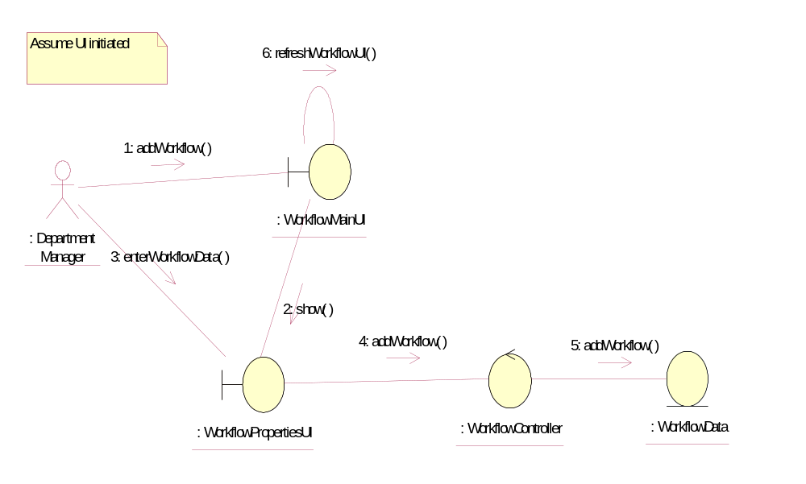

Initiate \ Update Workflow UI
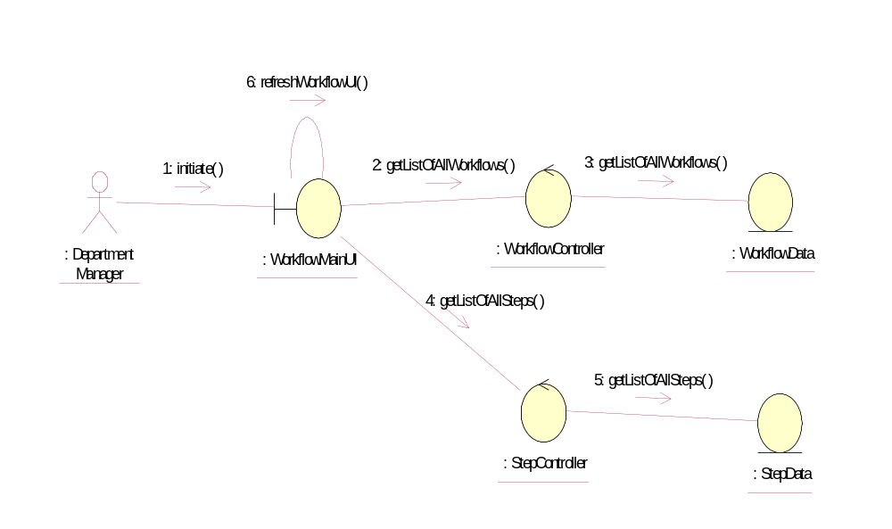

Activate \ Deactivate Workflow
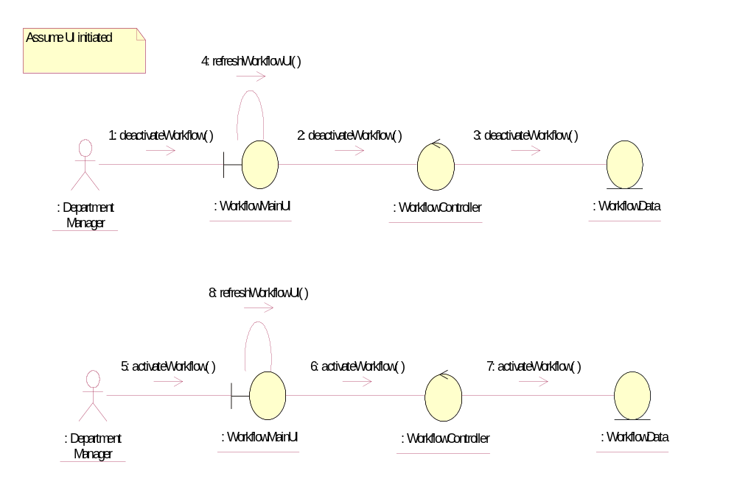

Add Step
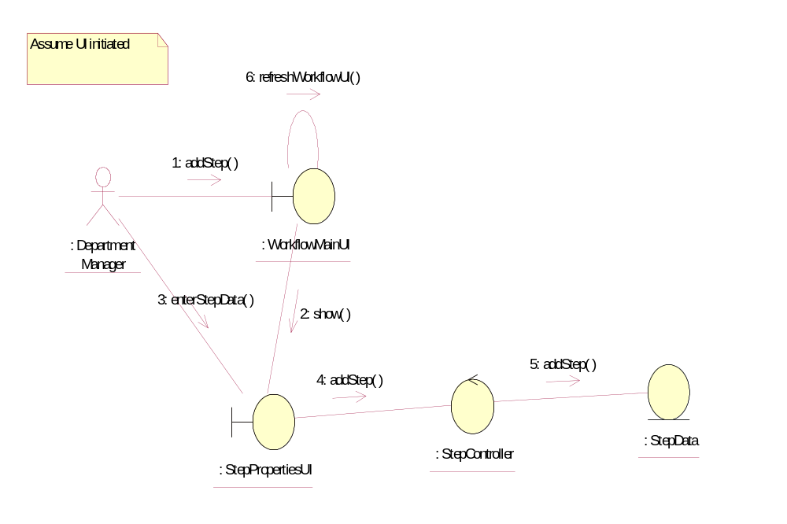

Modify Workflow Properties
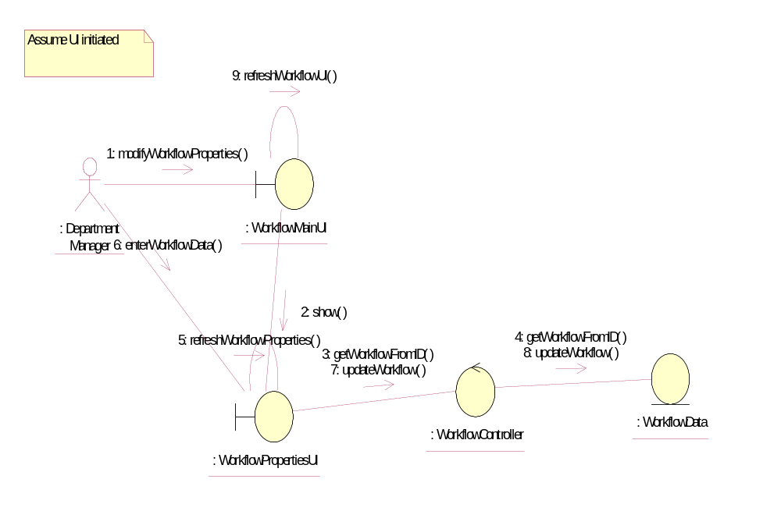

Modify Step Properties
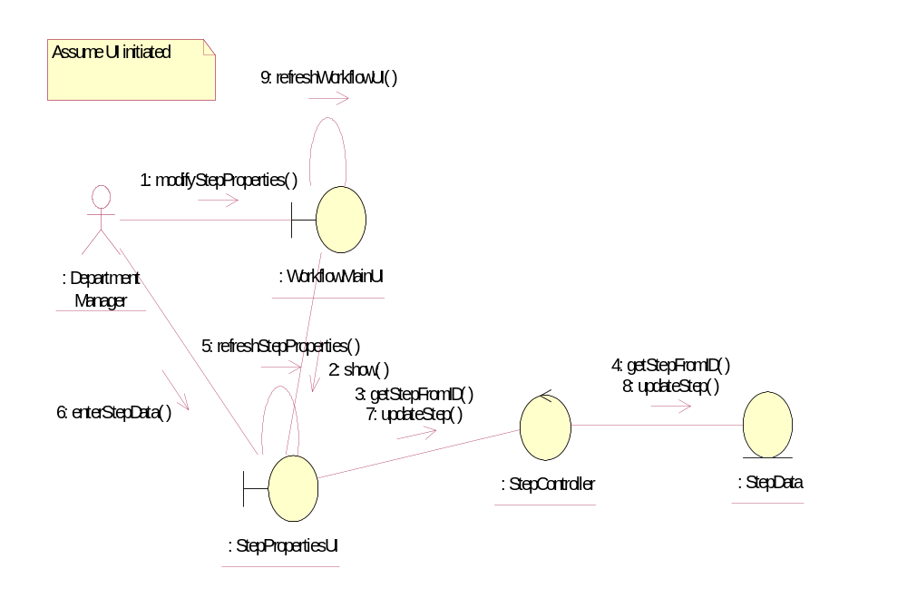

Activate \ Deactivate Step
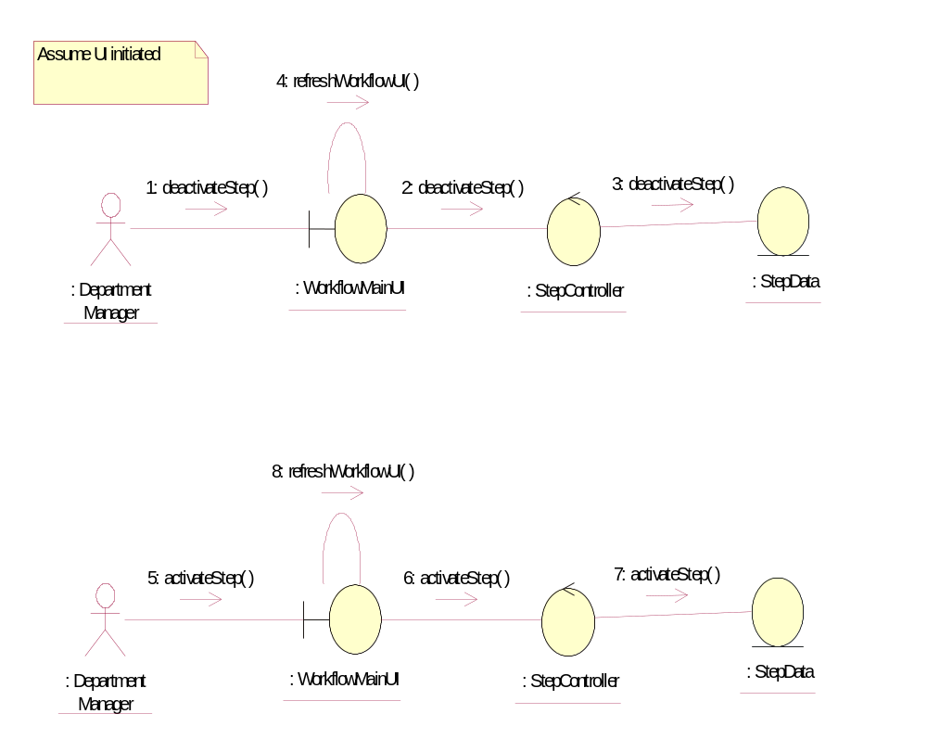

View Workflow
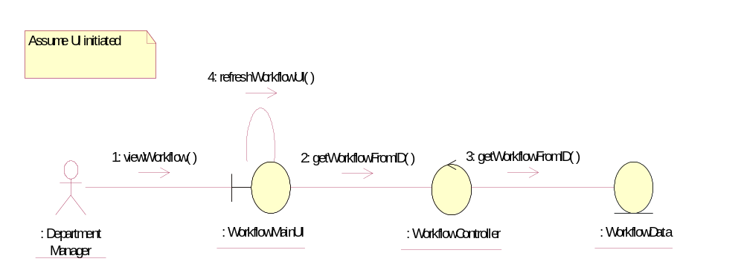

Modify Workflow-Step Relationship
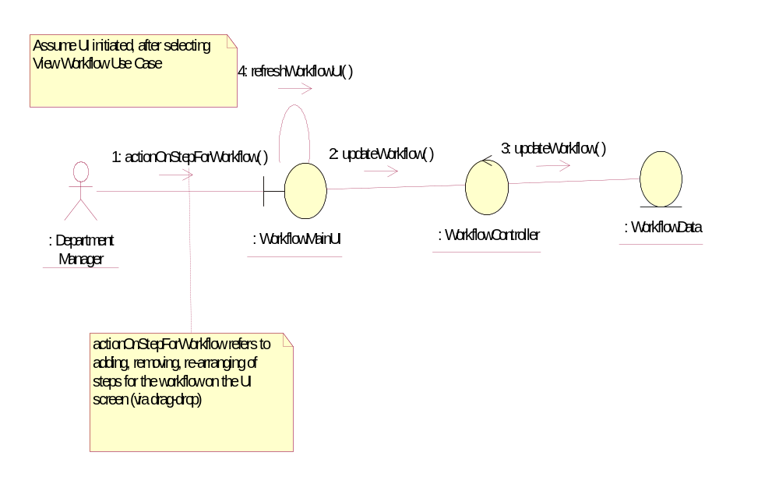

Participating Objects
: Department Manager
This actor represents the Department Manager of Golden Gravure.

: StepController
This object controls the operations of the step object.

: StepData
This object contains information about the step.

: StepPropertiesUI
This represents the UI where the Department Manager will add / de(activate) the steps.

: WorkflowController
This object controls the operations of the workflow object.

: WorkflowData
This object contains information about the workflow.

: WorkflowMainUI
This represents the UI where the user of the system will first enter, and act as a launchpad for the other various pages within the system.

: WorkflowPropertiesUI
This represents the UI where the Department Manager will add / de(activate) the workflows.

Class Diagrams

Manage Workflow-Step
